Statistical Genetics – Practical 3
Linkage Disequilibrium and Haplotype Estimation
Date: 29/09/2026
Submission deadline: 05/10/2026

1. Linkage Disequilibrium
1.1. Loading and description of the FOXP2 dataset
The FOXP2 dataset contains genotype information for unrelated individuals from a Japanese population. The genotype data were loaded into R from the FOXP2.dat file.
The resulting dataset contains:
- 104 individuals
- 543 SNPs
- 0 missing genotypes
Therefore, the percentage of missing data is:
$$\text{Percentage missing}=0\%$$
Thus, the dataset is complete and does not contain missing genotype information.

1.2. Linkage disequilibrium between rs34684677 and rs2894715
The linkage disequilibrium statistic $D$was calculated using the LD function from the genetics package.
The resulting value was:
$$D=-0.05494$$
The negative value indicates that the observed frequency of one particular haplotype combination is lower than would be expected under linkage equilibrium.
For the two SNPs, the observed genotypes were:
rs34684677
- G/G
- G/T
- T/T
rs2894715
- T/T
- T/G
- G/G
The corresponding LD analysis indicates an association between the alleles of the two SNPs. The negative value of $D$indicates that the two loci are not completely independent.
The magnitude of $D$, however, should be interpreted together with its statistical significance rather than by its sign alone.

1.3. Haplotype frequencies
Using the estimated value of $D$, the haplotype frequencies for the two SNPs were obtained as follows:
Haplotype | Estimated frequency
G-T | 0.500074
G-G | 0.336464
T-T | 0.163388
T-G | 0.000074
The frequencies sum approximately to one:
$$0.500074+0.336464+0.163388+0.000074≈1$$
The G-T haplotype is the most common, with an estimated frequency of approximately 50.0%.
The T-G haplotype is extremely rare, with a frequency of approximately $7.4×{10}^{-5}$.
These frequencies are consistent with the negative value of $D$, because some allele combinations occur considerably more frequently than others.

1.4. Hardy-Weinberg equilibrium
Genotype counts were determined for all 543 SNPs, and Hardy-Weinberg equilibrium was tested using the ordinary chi-square test without continuity correction.
The genotype counts were calculated using the allele information contained in the .bim file.
For example, the first six variants produced the following genotype counts:
SNP | AA | AB | BB
rs34684677 | 3 | 28 | 73
rs1839115 | 8 | 28 | 68
rs4727804 | 8 | 28 | 68
rs4727805 | 0 | 15 | 89
rs200888633 | 17 | 46 | 41
rs12534908 | 8 | 28 | 68
Among the 543 variants, 33 SNPs rejected the null hypothesis of Hardy-Weinberg equilibrium at the chosen significance level.
This corresponds to:
$$\frac{33}{543}×100=6.08\%$$
Therefore, approximately 6.08% of the variants were significantly different from Hardy-Weinberg equilibrium.
This result is somewhat higher than the approximately 5% expected when using a significance level of $α=0.05$. However, with 543 independent tests, the expected number of significant results by chance alone would be approximately:
$$543×0.05=27.15$$
The observed value of 33 is therefore reasonably close to the number expected by chance. Consequently, the result does not necessarily indicate a systematic violation of Hardy-Weinberg equilibrium.
It should also be noted that many SNPs are not independent because of linkage disequilibrium, which affects the interpretation of the number of significant tests.

1.5. Linkage disequilibrium across all marker pairs
Pairwise linkage disequilibrium was calculated for all 543 SNPs using the LD function from the genetics package.
The resulting object contained the following statistics for every pair of markers:
- $D$
- $D^{'}$
- $r$
- $R^{2}$
- number of observations
- $X^{2}$
- P-value
The $R^{2}$matrix had dimensions:
$$543×543$$
The diagonal and undefined comparisons generated missing values. In total, the matrix contained 147,696 NA values.
Considering the available pairwise comparisons, the $R^{2}$values ranged from approximately:
$$2.03×{10}^{-11}$$
to
$$0.999653$$
The median $R^{2}$was approximately 0.0195, while the mean was approximately 0.0977.
An LD heatmap was generated using the $R^{2}$statistic.
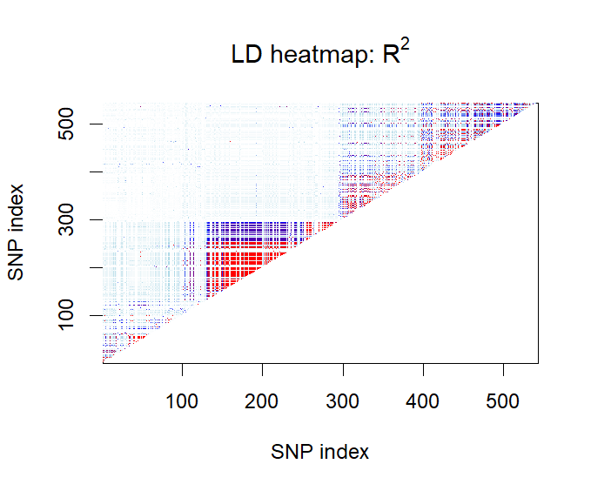
Figure 1. Heatmap showing pairwise linkage disequilibrium between the 543 FOXP2 SNPs. The colour scale represents the $R^{2}$statistic, with higher values indicating stronger linkage disequilibrium between pairs of variants.
The heatmap allows regions of high LD to be identified as blocks of similar colour. Strong LD is expected between physically close variants because recombination has had fewer opportunities to separate alleles at nearby loci.

1.6. LD heatmap after filtering variants with MAF < 0.35
The minor allele frequency (MAF) was calculated for every SNP. The distribution of MAF values was:
- Minimum: 0.01442
- First quartile: 0.04808
- Median: 0.21154
- Mean: 0.20313
- Third quartile: 0.27644
- Maximum: 0.49519
A total of 119 SNPs had MAF ≥ 0.35.
Therefore, the filtered dataset contained:
$$104×119$$
genotypes.
The LD calculation was repeated using these 119 variants, resulting in a:
$$119×119$$
$R^{2}$matrix.
The distribution of $R^{2}$values after filtering was:
Statistic | Value
Minimum | $$9.78×{10}^{-10}$$
1st quartile | 0.00389
Median | 0.17592
Mean | 0.29314
3rd quartile | 0.54309
Maximum | 0.999653
There were 7,140 missing entries in the matrix.
The filtered heatmap is shown below.
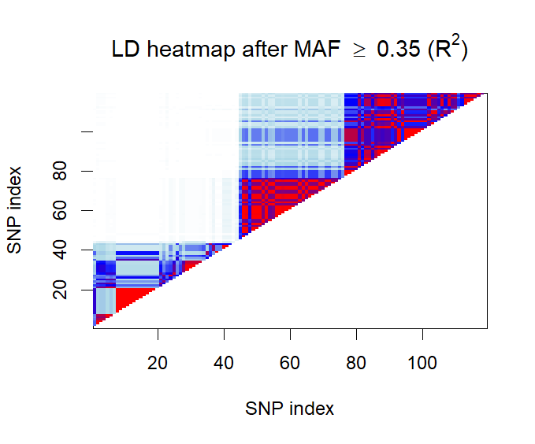
Figure 2. Heatmap of pairwise $R^{2}$values for FOXP2 variants with MAF ≥ 0.35.
The two heatmaps are expected to differ substantially. After filtering for common variants, the median $R^{2}$increased from approximately 0.0195 to 0.1759, and the mean increased from approximately 0.0977 to 0.2931.
This occurs because rare variants can produce unstable or less informative estimates of LD. In particular, when an allele is observed in only a small number of individuals, the possible haplotype combinations are limited and estimates of $R^{2}$can be strongly affected by sampling variation.
Consequently, restricting the analysis to relatively common variants produces a dataset in which LD estimates are generally more reliable and stronger LD patterns become more apparent.

1.7. Relationship between physical distance and LD
The physical distance between every pair of SNPs was calculated from their base-pair positions in the .bim file.
The resulting set contained 147,153 pairwise distances.
The distribution of distances was:
Statistic | Distance (bp)
Minimum | 0
1st quartile | 39,369
Median | 92,642
Mean | 104,003
3rd quartile | 154,839
Maximum | 299,353
The corresponding $R^{2}$values were extracted for the same SNP pairs.
A scatter plot was generated with physical distance on the x-axis and $R^{2}$on the y-axis.
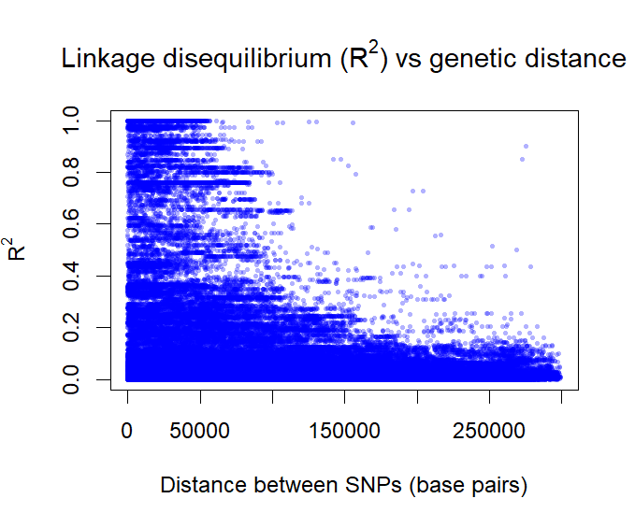
Figure 3. Relationship between physical distance between SNPs, expressed in base pairs, and linkage disequilibrium measured by $R^{2}$in the FOXP2 region.
To quantify the relationship, a Spearman rank correlation was calculated:
$$ρ=-0.3231$$
The correlation was statistically significant:
$$p<2.2×{10}^{-16}$$
The negative correlation indicates that LD tends to decrease as physical distance between SNPs increases.
This is biologically expected. SNPs that are physically close to each other are less likely to be separated by recombination, and therefore tend to be inherited together. As the physical distance increases, the probability of recombination between the markers also increases, resulting in lower LD.
The relationship is not perfect, as indicated by the moderate rather than very strong Spearman correlation. Other factors, including recombination hotspots, population history, mutation and genetic drift, also influence LD.

2. Haplotype Estimation
2.1. Description of the APOE dataset
The APOE dataset contains genotype information for unrelated individuals for SNPs located in the APOE gene region on chromosome 19.
After loading the data into R, the dataset contained:
- 107 individuals
- 162 SNPs
- 0 missing genotypes
The dimensions of the genotype data were therefore:
$$107×162$$
The .bim file contained 162 variants, and the SNP identifiers in the genotype data were confirmed to be in the same order as those in the .bim file.
All 107 individual identifiers were unique and none were missing.

2.2. Theoretical number of haplotypes
Assuming that all SNPs are biallelic, each SNP can contribute one of two possible alleles to a haplotype.
With 162 biallelic SNPs, the theoretical number of possible haplotypes is therefore:
$$2^{162}$$
which corresponds to:
$$\boxed{5.846×{10}^{48}}$$
possible haplotypes.
This is an enormous theoretical number. In practice, only a very small subset of these possible haplotypes is observed or estimated in a sample of 107 individuals.

2.3. Haplotype frequency estimation
Haplotype frequencies were estimated using the haplo.em function from the haplo.stats package.
Because phase is generally unknown from unphased genotype data, the EM algorithm is used to estimate the probabilities of the possible haplotypes compatible with the observed genotypes.
The estimated haplotypes should be reported in decreasing order of their estimated probabilities.
The most common haplotype is the haplotype with the highest estimated probability.
The number of haplotypes observed in the analysis is expected to be substantially smaller than the theoretical $2^{162}$possibilities. This is because the sample contains only 107 individuals and because the SNPs are not independent. Linkage disequilibrium restricts the combinations of alleles that occur together, resulting in a much smaller number of common haplotypes.

2.4. Effect of filtering variants with MAF < 0.10
Variants with a minor allele frequency below 0.10 were removed from the APOE dataset. The haplotype estimation was then repeated using the remaining variants.
The filtering procedure removes rare variants and therefore reduces the number of possible allele combinations. Consequently, the number of haplotypes estimated by the EM algorithm is expected to decrease.
The reduction in the number of haplotypes can be explained by the fact that rare variants contribute relatively uncommon allelic combinations. Removing these variants simplifies the haplotypic structure of the region and leaves a smaller set of haplotypes composed mainly of common alleles.
This illustrates the strong effect that allele frequency has on haplotype diversity. Although the theoretical number of haplotypes is extremely large, the number of haplotypes actually supported by the data is much smaller.

3. Conclusions
The analyses performed in this practical illustrate two important concepts in statistical genetics: linkage disequilibrium and haplotype structure.
For the FOXP2 region, 104 individuals and 543 SNPs were analysed with no missing genotype data. The analysis of the pair of SNPs rs34684677 and rs2894715 produced a negative LD coefficient ($D=-0.05494$), indicating that the allele combinations at the two loci are not independent.
The most common inferred haplotype for these two SNPs was G-T, with an estimated frequency of approximately 0.50.
The Hardy-Weinberg analysis identified 33 SNPs (6.08%) showing significant deviations from equilibrium. This number is reasonably close to the approximately 27 significant results expected by chance when 543 independent tests are performed at a 5% significance level.
The genome-wide LD analysis within the FOXP2 region showed that $R^{2}$generally decreases as physical distance increases. This was supported by a Spearman correlation of $-0.3231$, with $p<2.2×{10}^{-16}$. This negative association is consistent with the effect of recombination on linkage disequilibrium.
Filtering the FOXP2 variants according to MAF substantially changed the LD distribution. After retaining only variants with MAF ≥ 0.35, the median $R^{2}$increased from approximately 0.0195 to 0.1759. This demonstrates that allele frequency has an important effect on the estimation and interpretation of LD.
For the APOE region, 107 individuals and 162 SNPs were analysed, again with no missing genotypes. Although $2^{162}$haplotypes are theoretically possible under a biallelic model, only a small fraction of these can be supported by the available sample. Haplotype estimation with the EM algorithm provides a practical way of identifying the most probable haplotypes from unphased genotype data. Filtering out rare variants is expected to reduce the number of inferred haplotypes and simplify the haplotype structure.
Overall, the results demonstrate how physical distance, allele frequency and recombination contribute to the observed patterns of linkage disequilibrium and haplotype diversity in genomic data.

